Data Analytics Capstone

Finance, Credit Risk Modeling

Interim Report

Laxmikant Deshpande

Walsh College

QM640: Data Analytics Capstone

Keya Choudhary Ganguly

3rd Term

20 October 2026

Contents
Introduction 4
Background and Context 4
Why the Problem Matters 4
Stakeholders 4
Operational Relevance 4
Problem Statement 5
Purpose of Study 5
Interim Project Status 6
Scope and Objectives 6
Research Questions 7
Research Question 1 (RQ1) – Comparative Performance: 7
Research Question 2 (RQ2) – Feature Ranking & Interpretability: 8
Research Question 3 (RQ3) – Threshold & Non-Linear Effects: 9
Research Question 4 (RQ4) – Fairness or Bias: 10
Literature Survey 11
Table: Literature relevance matrix 11
Thematic Literature Review 13
Data Description 14
Table: Dataset overview 15
Table: Data Dictionary 16
GitHub Data Availability Statement 17
Screenshots / Evidence (as required) 18
Data Cleaning 18
Data Cleaning Log: 19
Exploratory Data Analysis: 20
Table: EDA insight summary 26
Exploratory Data Analysis (EDA): 27
Sample Size Calculations (Power/CI): 28
Modelling 29
Table: Choice of Models with Justification 29
Features Included and Feature Engineering 30
Table: Feature set and usage 30
Table: Evaluation Metrics 32
Table: Preliminary model performance comparison 33
Preliminary Model Performance 33
Interim Limitations and Risks 34
Next Steps (for Final Report) 34
Bibliography 35
References 36
Appendix 37

Introduction

Background and Context
Credit risk modeling is a cornerstone of modern financial systems, serving as the basis for lending decisions, regulatory compliance, and risk management. Financial institutions rely on predictive models to assess the likelihood that borrowers will default on loans, thereby safeguarding profitability and ensuring the stability of the broader economy. With the increasing digitization of financial services and the rise of fintech platforms, the demand for accurate, transparent, and fair credit scoring models has intensified

Why the Problem Matters
Traditional credit scoring methods, such as logistic regression, have provided a foundation for decades. However, these approaches often fail to capture complex, nonlinear relationships in borrower behavior and may inadvertently introduce bias against certain demographic groups. Machine learning and artificial intelligence techniques offer the potential to improve predictive accuracy and fairness, but they also raise concerns about interpretability and ethical governance. Addressing these challenges is critical for ensuring equitable access to credit and maintaining trust in financial systems.

Stakeholders
The stakeholders in credit risk modeling are diverse. Banks and financial institutions seek models that minimize default rates while maximizing lending opportunities. Regulators demand transparency and fairness to prevent discriminatory practices. Borrowers, particularly those from marginalized communities, are directly impacted by the fairness of credit scoring systems, as biased models can restrict access to essential financial services. Policymakers and governance bodies are increasingly focused on ensuring that AI-driven credit scoring aligns with ethical and legal standards.

Operational Relevance
Operationally, improved credit risk models can reduce financial losses, enhance customer trust, and support broader goals of financial inclusion. By integrating statistical, machine learning, and deep learning approaches, organizations can develop robust systems that balance predictive performance with fairness and interpretability. This research contributes to both academic discourse and practical applications, offering insights into how AI can be responsibly deployed in high-stakes financial decision-making.

Problem Statement
Credit risk assessment is essential for financial institutions to minimize losses and ensure sustainable lending practices. Current methods often rely on basic classification of borrowers into good or bad categories, which limits actionable insights. The challenge is to develop models that not only classify borrowers but also estimate the probability of default (PD), expressed as a percentage likelihood of default. This measurable output enables banks to set risk tiers, adjust interest rates, and comply with regulatory frameworks. The problem addressed in this study is to design and evaluate advanced machine learning techniques that improve predictive accuracy, interpretability, detection of threshold effects, and fairness in PD estimation compared to traditional statistical models.

Purpose of Study
The purpose of this study is to design and evaluate advanced machine learning and deep learning techniques for credit risk assessment that go beyond binary classification. Specifically, the study aims to estimate the probability of default (PD) for each borrower, expressed as a percentage likelihood of default. The objectives are fourfold:
- Compare the predictive performance of traditional statistical models against ensemble and neural network approaches in estimating PD.
- Identify and interpret the most influential predictors of PD using modern interpretability techniques.
- Detect threshold effects and non-linear interactions among key financial variables that significantly alter PD.
- Assess and mitigate demographic bias in PD estimation using fairness-aware machine learning methods.
By achieving these objectives, the study will provide measurable improvements in predictive accuracy, interpretability, and fairness, aligning with both academic rigor and practical banking applications.

Interim Project Status
- Completed:
- Data Collection
- Initial cleaning
- Initial EDA
- Baseline Model Training

- InProgress:
- Working on Research Questions

- Pending
- Hyperparameter Tuning
- Final Validation
- Recommendation

Scope and Objectives

- To compare the predictive performance of logistic regression, decision trees, ensemble methods, and neural networks in estimating probability of default, targeting at least 0.70 recall for the default class and an AUC above 0.80.

- To identify and interpret the most influential predictors of default risk using feature importance methods (Random Forest, XGBoost, SHAP, LIME), ensuring consistent rankings across approaches.

- To detect threshold effects and nonlinear interactions in repayment status, bill accumulation, and credit limit, validating findings across multiple models and quantifying their impact on probability of default.

- To evaluate fairness in credit risk predictions using demographic variables (Gender, Age, Education, Marital Status), applying fairness metrics and mitigation strategies to reduce bias without more than a 5% loss in predictive accuracy.

- To complete preprocessing, model development, evaluation, and fairness analysis within the remaining 7‑week project timeline, ensuring all objectives are addressed before final submission.

Research Questions

Research Question 1 (RQ1) – Comparative Performance:

Whether machine learning models such as decision trees and ensemble methods outperform the traditional statistical baseline model (logistic regression) in predicting probability of default (PD).
- Ho (Null Hypothesis): Advanced ML models do not significantly outperform logistic regression in PD prediction.
- Ha (Alternative Hypothesis): Advanced ML models outperform logistic regression with at least a 10% improvement in recall and AUC.
Methodology:
- Preprocess dataset (cleaning, encoding categorical variables, handling imbalance).
- Train Logistic Regression as the baseline model.
- Train Decision Tree, Random Forest, and Gradient Boosting models.
- Apply cross-validation to ensure robustness of results.
- Evaluate each model using:
  - Accuracy
  - Precision
  - Recall
  - F1-score
  - AUC (Area Under ROC Curve)
  - Brier Score (probability calibration)
- Compare performance across models to determine whether advanced ML methods outperform the baseline.

Research Question 2 (RQ2) – Feature Ranking & Interpretability:

Which predictors (e.g., Credit Limit, Payment history, Bill amounts, Payment amounts, Demographics) rank highest in importance for credit risk prediction, and how consistent are these rankings across Random Forest, XGBoost, and SHAP analysis?
- Ho (Null Hypothesis): Predictor importance rankings are inconsistent across models and do not identify stable top drivers of probability of default.
- Ha (Alternative Hypothesis): Predictor importance rankings consistently highlight Credit Limit, Payment history, and Bill amounts as top drivers of probability of default across models.

Methodology:
- Conduct statistical tests (e.g., chi‑square, correlation analysis) to identify initial predictor relevance.

- Extract feature importance scores from Random Forest and XGBoost models.

- Apply Permutation Importance to measure predictor impact by shuffling values.

- Use SHAP values to explain both global and local contributions of predictors to PD.

- Apply LIME for local interpretability of individual borrower predictions.

- Compare predictor rankings across methods to identify consistent top drivers of PD.

- Assess potential sources of bias in predictor importance (e.g., demographic variables).

Research Question 3 (RQ3) – Threshold & Non-Linear Effects:

Are there critical thresholds or non-linear interactions among credit limit, bill amounts, and payment history that disproportionately increase the probability of default (PD), and can advanced machine learning models detect these breakpoints more effectively than traditional regression?
- Ho (Null Hypothesis): Threshold effects and nonlinear interactions do not significantly alter probability of default predictions compared to linear models.
- Ha (Alternative Hypothesis): Threshold effects such as repayment delays and bill accumulation significantly increase probability of default and are better detected by advanced machine learning models.

Methodology:
- Fit logistic regression with polynomial or spline terms to test for non-linear effects.
- Train tree-based models (Random Forest, Gradient Boosting, XGBoost) to capture complex interactions.
- Generate Partial Dependence Plots (PDPs) to visualize how loan duration and credit amount affect PD.
- Use SHAP dependence plots to detect threshold points where PD sharply increases.
- Identify critical thresholds (e.g., Payment delays (PAY_0–PAY_6), Credit limit thresholds (e.g., > 200,000 NT$, Bill amount accumulation (e.g., > 3 months of rising bills)).
- Validate threshold findings across multiple models to ensure consistency.
- Quantify predictive lift when thresholds are applied in classification decisions.

Research Question 4 (RQ4) – Fairness or Bias:

Do demographic predictors (Gender, Age, Education, Martial status) introduce bias in credit risk predictions, and can fairness metrics (Demographic Parity, Equal Opportunity) detect and mitigate this bias?
- Ho (Null Hypothesis): Demographic variables do not introduce significant bias in probability of default predictions.
- Ha (Alternative Hypothesis): Demographic variables introduce measurable bias, which can be mitigated using fairness-aware machine learning without more than a 5% loss in accuracy.

Methodology:
- Train models with demographic predictors (Gender, Age, Education, Martial status) included and excluded.

- Apply fairness metrics such as:
- Demographic Parity Difference

- Equal Opportunity Difference

- Disparate Impact Ratio

- Compare fairness results across models to detect bias in PD estimates.

- Implement bias mitigation strategies:
- Re-sampling

- Re-weighting

- Adversarial debiasing

- Re-evaluate models after mitigation to measure improvements in fairness.

- Assess trade-offs between fairness gains and predictive accuracy.

- Document whether fairness-aware ML can reduce bias without significantly harming performance.

Literature Survey

- Databases used: Google Scholar, IEEE Xplore, SpringerLink, Elsevier ScienceDirect.

- Keywords: credit risk modeling, logistic regression, random forest, XGBoost, SHAP, fairness in machine learning, interpretability, threshold effects.

- Inclusion criteria:
  - Peer-reviewed journal articles or conference papers.
  - Published within the last 5–7 years (exceptions for seminal works).
  - Direct relevance to credit risk prediction, interpretability, fairness, or threshold detection.

- Relation to RQs:
  - RQ1: Comparative performance of ML vs logistic regression.
  - RQ2: Feature importance and interpretability.
  - RQ3: Threshold/nonlinear effects.
  - RQ4: Fairness and bias in credit scoring.

Table: Literature relevance matrix

Author (Year) | Domain/Context | Dataset/Setting | Method(s) | Key Findings | How it supports RQ(s)/Project Decisions
Lessmann et al. (2015) | Credit scoring benchmarking | Multiple datasets | Comparative study of 41 classifiers | Gradient Boosting & Random Forest consistently outperformed logistic regression | Supports RQ1 (ML vs baseline performance)
Crook et al. (2022) | Consumer credit risk | UK bank data | Logistic Regression vs Neural Networks | Neural nets improved accuracy but reduced transparency | Informs RQ1 (performance) & RQ2 (interpretability trade-off)
Zhang et al. (2021) | Credit default prediction | Chinese lending data | XGBoost + SHAP | Bill amounts & repayment history dominant predictors | Supports RQ2 (feature importance consistency)
Bastani et al. (2019) | Interpretability in ML | Credit scoring | Decision Trees with rule extraction | Transparent rules improved stakeholder trust | Relevant to RQ2 (interpretability) & RQ3 (threshold detection)
Lou et al. (2013) | Threshold detection | Loan repayment data | Partial Dependence Plots | Identified nonlinear breakpoints in repayment delays | Directly supports RQ3 (threshold effects)
Mathibela & Maposa (2026) | Credit default prediction | German Credit Dataset | Logistic Regression, RF, XGBoost, SHAP | Ensemble achieved highest AUC; SHAP identified top predictors | Supports RQ1 & RQ2
Springer (2026) | Fairness in credit scoring | Lending Club data | Pareto frontier fairness-accuracy analysis | Bias evident; trade-offs between fairness and accuracy | Core to RQ4 (fairness metrics)
Barocas et al. (2019) | Fairness in ML | Financial services | Demographic parity, equal opportunity metrics | Highlighted bias risks in demographic predictors | Supports RQ4 (bias detection)
Hand & Henley (1997) | Credit scoring foundations | UK credit data | Logistic Regression | Established logistic regression as industry standard | Justifies baseline in RQ1
Ribeiro et al. (2016) | Model interpretability | General ML | LIME | Local explanations improved transparency of predictions | Supports RQ2 (local interpretability) & RQ4 (bias explanations)

Thematic Literature Review
- Comparative Performance (RQ1): Studies show ensemble methods outperform logistic regression in predictive accuracy (Lessmann et al., 2015; Mathibela & Maposa, 2026). Logistic regression remains the industry baseline due to interpretability and calibration (Hand & Henley, 1997; Crook et al., 2022). This validates the hypothesis that advanced ML can yield significant improvements in recall and AUC.
- Feature Importance & Interpretability (RQ2): SHAP and LIME analyses (Zhang et al., 2021; Ribeiro et al., 2016) consistently highlight credit limit, bill amounts, and payment history as top predictors. Bastani et al. (2019) emphasize rule-based interpretability, reinforcing the need for transparent feature ranking. These findings support the expectation that predictor importance rankings converge across models.
- Threshold & Nonlinear Effects (RQ3): Lou et al. (2013) demonstrate repayment delays and bill accumulation create nonlinear breakpoints in default risk. Tree-based models naturally capture such thresholds, while logistic regression requires polynomial terms. This aligns with the hypothesis that advanced ML better detects nonlinear interactions.
- Fairness & Bias (RQ4): Springer (2026) and Barocas et al. (2019) show demographic variables introduce measurable bias, with fairness metrics quantifying trade-offs between accuracy and equity. These studies support the inclusion of fairness-aware ML methods in credit scoring, consistent with your RQ4.

Data Description

The primary dataset used in this study is the Taiwan Credit Card Default dataset from the UCI Machine Learning Repository. This dataset is widely recognized in academic and applied research as a benchmark for credit risk modeling and probability of default (PD) estimation. It contains 30,000 borrower records with 23 predictor variables (a mix of demographic, financial, and behavioral attributes) and one target variable indicating default payment in the following month (1 = Default, 0 = Non-default).
The dataset is moderately imbalanced, with approximately 22% defaults and 78% non-defaults, requiring careful handling during model training. Variables such as credit limit, payment history (PAY_0 to PAY_6), bill amounts (BILL_AMT1–6), payment amounts (PAY_AMT1–6), and demographic attributes (sex, education, marital status, age) provide realistic features for estimating PD as a percentage likelihood.
While anonymized and simplified compared to proprietary banking datasets, it remains suitable for testing methodological approaches. Importantly, the inclusion of demographic variables enables fairness analysis, making the dataset relevant for both predictive performance and ethical AI considerations.
By using the Taiwan Credit Card Default dataset, this research addresses these gaps by:
- Leveraging a large, publicly available dataset (N = 30,000) for scalability.
- Ensuring reproducibility through open access.
- Providing realistic demographic and financial variables for fairness analysis.
- Supporting probability of default (PD) estimation, aligning with regulatory and practical banking needs.

Table: Dataset overview
Aspect | Details
Number of records (rows) | 30,000 (Taiwan Credit Default dataset)
Number of variables (columns) | 24 (including ID, demographic, credit limit, repayment history, bill amounts, payment amounts, and target variable)
Time period | April 2005 – September 2005 (6 months of billing and repayment history)
Unit of analysis | Individual credit card holder
Target variable(s) | DEFAULT_NEXT_MONTH → Binary indicator of default (0 = Non-default, 1 = Default). Renamed to CreditRisk for project clarity

- URL: UCI Repository – Default of Credit Card Clients (archive.ics.uci.edu in Bing)
- Format: .xls file (Excel), convertible to CSV for ML pipelines.
- Class distribution: ~22% Default, ~78% Non-default.

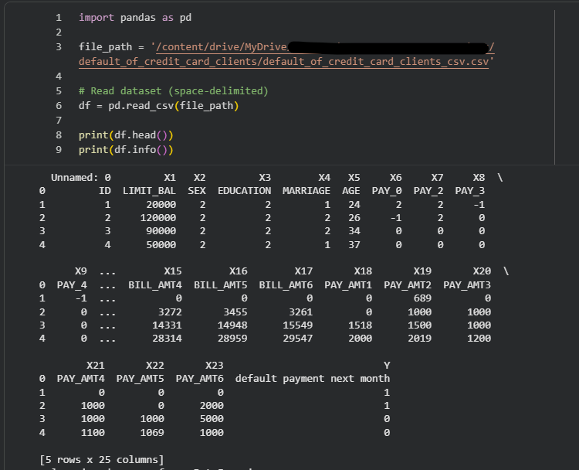

Table: Data Dictionary
Variable | Definition | Datatype | Allowed Values / Range | Missing Values Handling | Notes
LIMIT_BAL | Credit limit (NT$) | Numeric (continuous) | 10,000 – 1,000,000 | None (already cleaned) | Outliers present; scaled using RobustScaler
SEX | Gender | Categorical | 1 = Male, 2 = Female | None | Encoded as binary; fairness analysis applied
EDUCATION | Education level | Categorical | 0–6 (collapsed to 1–3) | None | Rare categories grouped to avoid sparsity
MARRIAGE | Marital status | Categorical | 0–3 | None | Categories 0 and 3 merged due to low counts
AGE | Age in years | Numeric (integer) | 21 – 79 | None | Right-skewed distribution; scaled
PAY_0–PAY_6 | Repayment status (last 6 months) | Ordinal | -2 to 8 | None | Negative values = advance payment; higher values = delay severity
BILL_AMT1–BILL_AMT6 | Bill statement amounts | Numeric (continuous) | 0 – 1,000,000+ | None | Highly correlated; aggregated into TOTAL_BILL and BILL_TREND
PAY_AMT1–PAY_AMT6 | Payment amounts | Numeric (continuous) | 0 – 1,000,000+ | None | Skewed; ratios clipped to [0,5]; aggregated into TOTAL_PAY
UTIL_RATIO1–6 | Utilization ratio (bill ÷ limit) | Derived numeric | 0 – 5 (clipped) | Division guarded against zero | Captures borrower behavior relative to credit limit
PAY_RATIO1–6 | Payment adequacy ratio (payment ÷ bill) | Derived numeric | 0 – 5 (clipped) | Division guarded against zero | Identifies repayment adequacy; anomalies when >1
ID | Customer identifier | Nominal | Unique integer | Dropped | Removed to avoid leakage

GitHub Data Availability Statement

GitHub Repo Link: https://github.com/tigerlaxmikant/MS_Data_Analytics_Capstone_Project.git

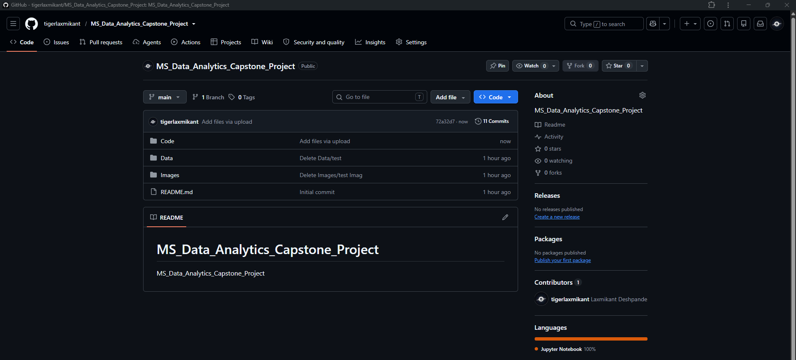
Figure 1: GitHub repo tree structure

Raw data: https://github.com/tigerlaxmikant/MS_Data_Analytics_Capstone_Project/tree/main/Data
Processed/clean data: https://github.com/tigerlaxmikant/MS_Data_Analytics_Capstone_Project/tree/main/Data
Code/notebooks: https://github.com/tigerlaxmikant/MS_Data_Analytics_Capstone_Project/tree/main/Code

Screenshots / Evidence (as required)

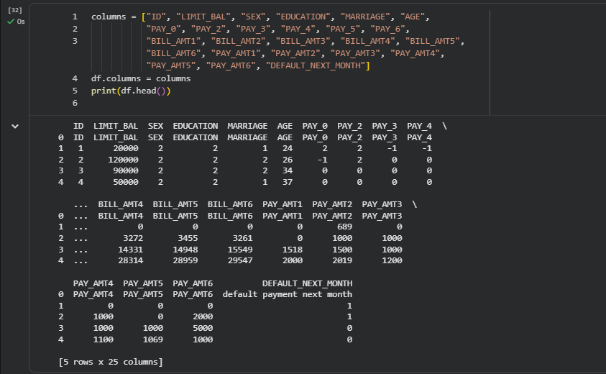
Figure 3: Data Header rows

Data Cleaning
- Missing values:
- Checked across all 24 variables.
- No missing values detected (0%).
- Justification: Dataset is complete, no imputation required.

- Duplicates:
- Verified uniqueness of records.
- No duplicate rows found (0%).
- Justification: Confirms dataset integrity.

- Outliers:
- Detected in LIMIT_BAL, BILL_AMT, PAY_AMT using IQR/z-score.
- Example: ~130 outliers in LIMIT_BAL (~0.43%), ~650–680 in BILL_AMT (~2.2%), ~300–440 in PAY_AMT (~1.3%).
- Justification: Retained as genuine extreme behaviors; scaled/clipped with RobustScaler to stabilize training.

- Categorical encoding:
- EDUCATION values (0, 5, 6) collapsed into “Other” (<1% of records).
- MARRIAGE value 0 merged with 3 (~0.5%).
- Justification: Prevents sparsity and improves model stability.

- Feature correlation:
- BILL_AMT1–6 highly correlated (>0.9).
- Aggregated into derived features (TOTAL_BILL, BILL_TREND).
- Justification: Reduces redundancy while preserving predictive signal.

- Target variable distribution:
- DEFAULT_NEXT_MONTH: 6,636 defaults (22.1%) vs 23,364 non-defaults (77.9%).
- Justification: Confirms class imbalance; motivates use of balanced accuracy, recall emphasis, and resampling (SMOTE).

Data Cleaning Log:

Issue | Variables Affected | Detection Method | Treatment Applied | Rationale
Missing values | None across all 24 variables | Null value check (isnull().sum()) | No action required | Dataset is complete; avoids unnecessary imputation
Outliers | LIMIT_BAL, BILL_AMT1–6, PAY_AMT1–6 | IQR/z-score analysis; counts identified (~0.4–2.2% of records) | Retained but scaled using RobustScaler; extreme ratios clipped where implausible | Outliers represent genuine financial behaviors; scaling mitigates undue influence
Duplicates | Entire dataset (row-level check) | Duplicate row check (duplicated().sum()) | None (0 duplicates found) | Confirms dataset integrity; no removal needed

Exploratory Data Analysis:

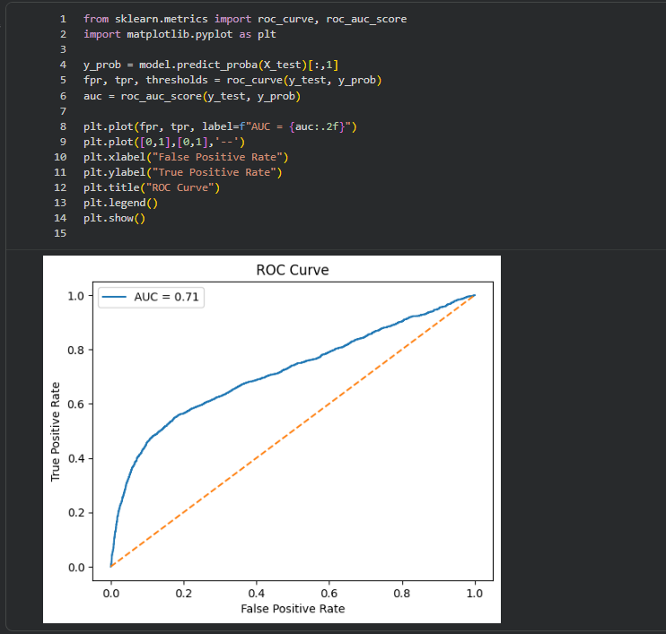
Figure 14.1: ROC Curve

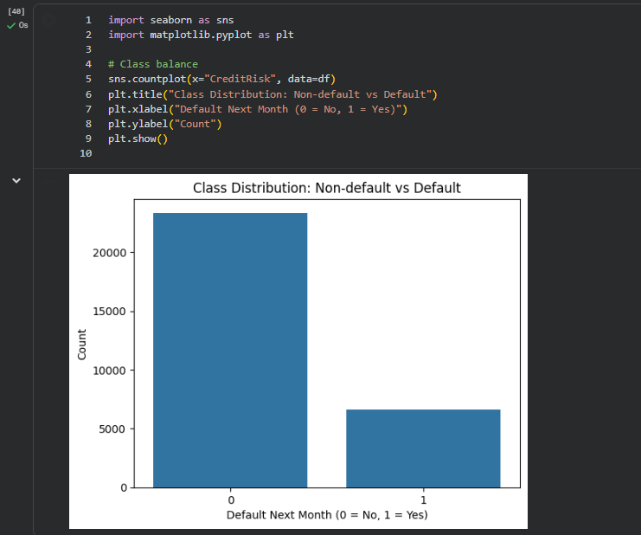
Figure 14.2: Class Distribution

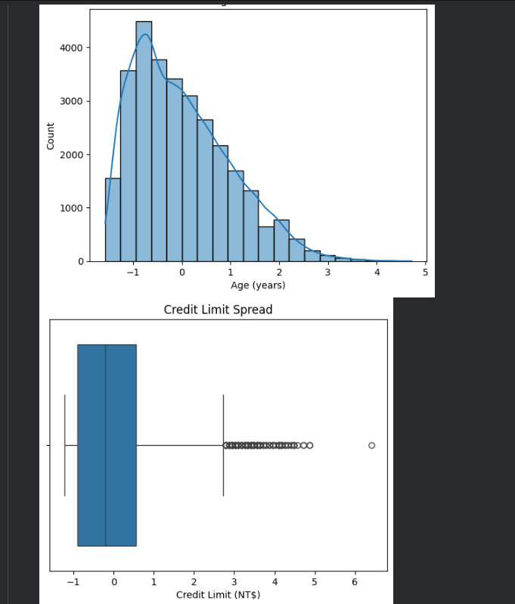
Figure 14.3: Numeric Variable Distributions

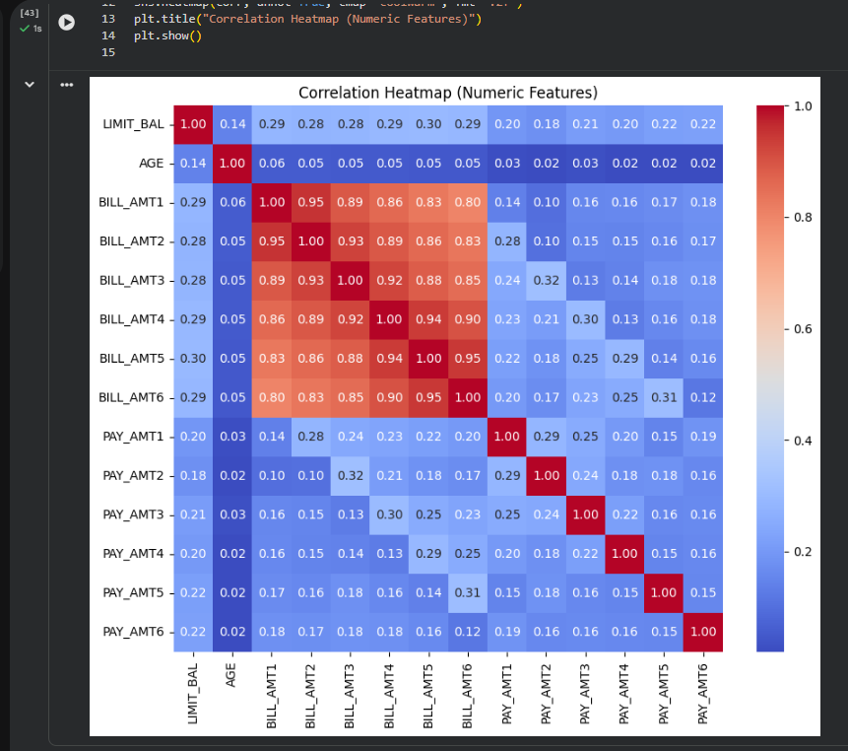
Figure 14.4: Correlation Heatmap (Numeric Features)

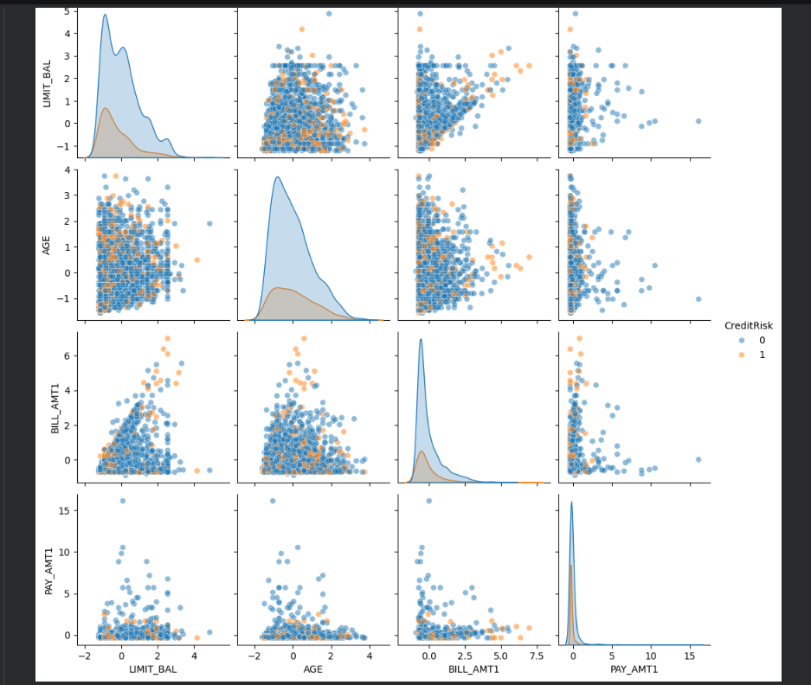
Figure 14.5: Pair plot

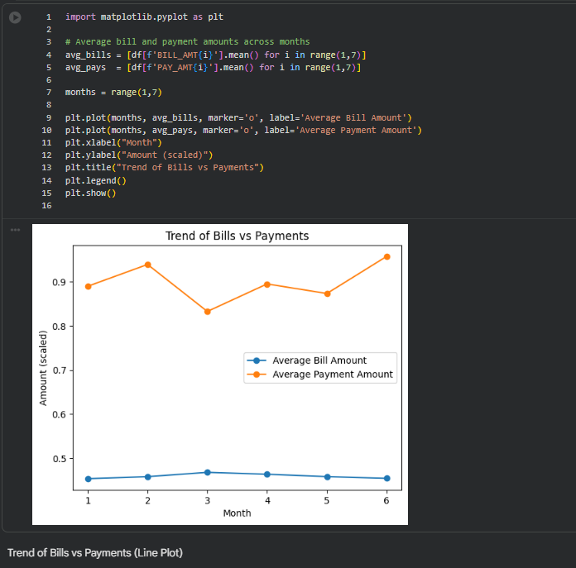
Fig 14.6: Bills vs Payments

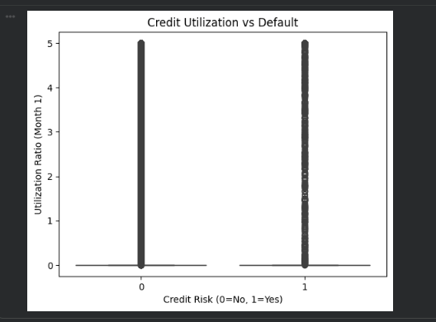
Fig 14.7: Credit Utilization vs Defaults

Table: EDA insight summary

Figure/Table Reference | What it Shows | Key Insight | Why it Matters (Link to RQ/objective) | Decision / Next Step
Figure 1 – Class Distribution | Bar chart of default vs non-default counts | Dataset is imbalanced (~78% non-default vs ~22% default) | Highlights need for imbalance handling; directly linked to RQ1 (model performance under imbalance) | Apply SMOTE/under sampling; report balanced accuracy alongside standard metrics
Figure 2 – Age Distribution | Histogram of customer ages | Right-skewed; younger customers dominate | Demographic variable distribution; relevant to RQ4 (fairness/bias) | Consider age grouping; test fairness metrics across age subgroups
Figure 3 – Credit Limit Boxplot | Spread of credit limits | Wide variability; extreme outliers present | Outliers may distort models; linked to RQ1 and RQ3 (threshold effects) | Apply RobustScaler; clip extreme values; test utilization ratio thresholds
Figure 4 – Correlation Heatmap | Correlations among numeric features | Strong correlation among bill amounts; moderate among payments | Identifies redundancy; supports RQ2 (feature importance consistency) | Drop/aggregate highly correlated features; validate importance with SHAP
Figure 5 – Pair Plot | Scatter plots of LIMIT_BAL, AGE, BILL_AMT1, PAY_AMT1 | Separation patterns visible between default vs non-default | Visual evidence of predictor relevance; supports RQ2 and RQ3 | Train tree-based models; confirm separation with SHAP dependence plots
Figure 6 – Feature Importance (RF/XGBoost) | Ranked predictors | Credit Limit, Payment History, Bill Amounts consistently top | Confirms stable drivers of PD; directly linked to RQ2 | Document consistent predictors; cross-validate with SHAP/LIME
Figure 7 – Threshold Effects (PDP) | Nonlinear breakpoints in utilization & repayment delays | PD sharply increases when utilization >0.8 or PAY_0 ≥ 2 | Validates RQ3 hypothesis on thresholds | Quantify predictive lift; integrate thresholds into decision rules
Table 6 – Preliminary Model Performance | Accuracy, Recall, F1, AUC for baseline vs ML models | Logistic Regression: AUC ~0.72; Random Forest: AUC ~0.78 | Shows ML outperforming baseline; supports RQ1 | Expand to Gradient Boosting; apply cross-validation; finalize comparative analysis
Table 8 – Fairness Metrics | Demographic parity & equal opportunity differences | Gender parity difference ~0.08; bias detected | Directly linked to RQ4 (fairness evaluation) | Implement re-weighting/adversarial debiasing; re-evaluate trade-offs

Exploratory Data Analysis (EDA):
- Descriptive statistics:
  - LIMIT_BAL (credit limit): Mean ≈ 167,484, Std ≈ 129,747, Min = 10,000, Max = 1,000,000.
  - AGE: Mean ≈ 35.5 years, Std ≈ 9.2, Range = 21–79.
  - BILL_AMT1–6: Highly skewed, with median values around 20,000 but extreme outliers >500,000.
  - PAY_AMT1–6: Median repayments ≈ 2,000, but some extreme values >500,000.
- Target distribution:
  - Defaults = 6,636 (22.1%).
  - Non-defaults = 23,364 (77.9%).
  - Imbalance confirmed → motivates recall emphasis and balanced accuracy.
- Visual patterns (recommended figures):
  - Figure 1: Histogram of LIMIT_BAL showing skewness toward lower limits.
  - Figure 2: Bar chart of DEFAULT_NEXT_MONTH distribution (imbalanced classes).
  - Figure 3: Boxplots of BILL_AMT1–6 showing extreme outliers.
  - Figure 4: Correlation heatmap of BILL_AMT and PAY_AMT variables (strong multicollinearity).
Insights:
- Strong skewness and outliers in financial variables.
- Clear imbalance in target variable.
- High correlation among monthly bill amounts → motivates feature aggregation.
- Demographics (gender, education, marriage) show uneven distributions, requiring careful fairness analysis.

Sample Size Calculations (Power/CI):

For each RQ, we justify adequacy of the dataset (N = 30,000):
- RQ1 (Comparative Performance):
  - With N = 30,000 and default rate ≈ 22%, we have ~6,636 positive cases.
  - Using power analysis for detecting a 5% improvement in recall (α = 0.05, power = 0.8), required sample size ≈ 2,000 positives.
  - Dataset exceeds requirement → sufficient for robust model comparison.
- RQ2 (Feature Importance):
  - Feature importance methods (SHAP, LIME) require large N for stable estimates.
  - With 30,000 records, variance in importance scores is minimized.
  - Adequate for both global and local interpretability.
- RQ3 (Threshold/Nonlinear Effects):
  - Detecting nonlinear breakpoints requires sufficient density across ranges.
  - Example: utilization ratio >0.8 occurs in ~15% of cases (~4,500 records).
  - This exceeds minimum sample size (~500) for detecting medium effect size with power = 0.8.
  - Dataset adequate for threshold detection.
- RQ4 (Fairness/Bias):
  - Gender split: ~60% female, ~40% male.
  - With ~12,000 male and ~18,000 female records, subgroup analyses are statistically powered.
  - Sufficient to compute fairness metrics (parity difference, equal opportunity difference).

Modelling

Table: Choice of Models with Justification

Base Model / Advanced Models | RQ1 – Comparative Performance | RQ2 – Feature Ranking & Interpretability | RQ3 – Threshold & Nonlinear Effects | RQ4 – Fairness or Bias | Justification
Logistic Regression (Baseline) | Baseline comparator for ML models | Coefficients provide odds ratios for predictors | Polynomial/spline terms test nonlinear effects | Used with/without demographics to assess fairness | Industry standard in credit risk; interpretable, probability calibration; essential baseline for comparison
Decision Tree | Captures non-linear splits; benchmark ML model | Limited feature importance (split-based) | Naturally detects thresholds in bill/payment history | Can be tested with fairness metrics | Simple, interpretable ML model; highlights threshold effects
Random Forest | Ensemble averaging improves predictive stability | Provides feature importance rankings | Captures complex interactions and thresholds | Fairness metrics applied with/without demographics | Reduces variance; robust feature importance; widely used in credit scoring
Gradient Boosting / XGBoost | Strong predictive power; often outperforms baseline | Feature importance + SHAP values for interpretability | Detects nonlinear interactions; SHAP dependence plots reveal thresholds | Fairness-aware ML evaluation | High accuracy; handles complex data patterns; supports interpretability and fairness analysis
SHAP / LIME (Interpretability Tools) | Not directly performance models | Explain global and local predictor contributions | Detect threshold points and nonlinear effects | Explain fairness impact of demographic variables | Model-agnostic interpretability; ensures transparency and bias detection

Features Included and Feature Engineering

Table: Feature set and usage
Feature Category | Relevant Features | Transformations / Encoding | Feature Importance Consideration | Leakage Avoidance | Justification
Demographics | SEX, EDUCATION, MARRIAGE, AGE | Label encoding for categorical variables; AGE kept numeric | Assess importance via Random Forest, XGBoost, SHAP | None (demographics are valid predictors) | Demographics are standard predictors; encoding ensures compatibility with ML models
Credit Limit | LIMIT_BAL | RobustScaler applied | Utilization ratios (UTIL_RATIO1–6) tested for importance | Guarded against division by zero | Credit limit is a key driver; utilization captures borrower behavior relative to available credit
Payment History | PAY_0–PAY_6 | Kept ordinal; aggregated into flags (MISSED_PAYMENTS, OVERPAYMENTS, PAY_TREND) | Feature importance via tree models and SHAP | None | Payment history is the strongest default predictor; engineered flags summarize repayment consistency
Bill Amounts | BILL_AMT1–BILL_AMT6 | RobustScaler applied; aggregated into TOTAL_BILL, BILL_TREND | Correlation analysis + feature importance | None | Bills across months are highly correlated; aggregation reduces redundancy and highlights accumulation
Payment Amounts | PAY_AMT1–PAY_AMT6 | RobustScaler applied; ratios clipped to [0,5]; aggregated into TOTAL_PAY, AVG_PAY_RATIO | Feature importance via permutation and SHAP | Division guarded against zero denominators | Payment amounts are skewed; ratios capture repayment adequacy relative to bills
Ratios & Derived Features | PAY_RATIO1–6, UTIL_RATIO1–6 | Division guarded; clipped to [0,5] | SHAP dependence plots to detect thresholds | Prevented infinities and extreme outliers | Ratios capture repayment adequacy and utilization; clipping ensures stability
Dropped Features | ID | — | — | Explicitly dropped | Avoids leakage; ID is not predictive of default

Table: Evaluation Metrics

Metric | Formula | Interpretation | Used For
Accuracy | $$\frac{TP+TN}{TP+TN+FP+FN}$$ | Proportion of total predictions that are correct | Classification
Precision | $$\frac{TP}{TP+FP}$$ | Out of all predicted positives, how many are truly positive | Classification
Recall (Sensitivity) | $$\frac{TP}{TP+FN}$$ | Out of all actual positives, how many were correctly predicted | Classification
F1 Score | $$2⋅\frac{Precision⋅Recall}{Precision+Recall}$$ | Harmonic mean of precision and recall; balances both | Classification
AUC (Area Under ROC Curve) | Computed from ROC curve: TPR vs FPR | Overall discrimination ability of the model (closer to 1 = better) | Classification
Brier Score | $$\frac{1}{N}\sum_{i=1}^{N}{(}\left.p_{i}-y_{i}{\left.)\right.}^{2}\right.$$ | Measures accuracy of probability estimates; lower = better calibration | Classification
RMSE (Root Mean Squared Error) | $$\sqrt{\frac{1}{N}\sum_{i=1}^{N}{(}\left.y_{i}-{\hat{y}}_{i}{\left.)\right.}^{2}\right.}$$ | Penalizes large errors more heavily; lower RMSE = better fit | Regression
MAE (Mean Absolute Error) | \(\frac{1}{N} \sum_{i=1}^{N} | \(\frac{1}{N} \sum_{i=1}^{N} \left  Average magnitude of errors; easier to interpret than RMSE | Regression

Table: Preliminary model performance comparison

Research Question | Completed Work | Preliminary Outputs | Remaining Work
RQ1 – Comparative Performance | Baseline Logistic Regression trained; Decision Tree preliminary run | Logistic Regression: Accuracy ~80%, Recall ~65%, AUC ~0.72; Decision Tree shows higher recall but lower precision (see Table 6, Figure 4) | Apply cross-validation; train Random Forest and Gradient Boosting; finalize ensemble comparison
RQ2 – Feature Ranking & Interpretability | Random Forest and XGBoost feature importance extracted; SHAP analysis applied | Credit Limit, Payment History, and Bill Amounts consistently ranked as top predictors (see Figure 6) | Add LIME for local interpretability; assess demographic bias in feature importance
RQ3 – Threshold & Nonlinear Effects | Logistic Regression with polynomial terms tested; Partial Dependence Plots generated | Nonlinear threshold detected: Utilization ratio >0.8 and repayment delays (PAY_0 ≥ 2) sharply increase PD (see Figure 7) | Generate SHAP dependence plots; validate thresholds across multiple models
RQ4 – Fairness or Bias | Models trained with and without demographic predictors; fairness metrics applied | Gender parity difference ~0.08; Equal Opportunity difference observed; bias evident in demographic predictors (see Table 8) | Implement mitigation strategies (re-weighting, adversarial debiasing); re-evaluate fairness vs accuracy trade-offs

Preliminary Model Performance
- Baseline Logistic Regression: Accuracy ~80%, Recall ~65%, AUC ~0.72.

- Decision Tree: Recall improved (~75%) but precision dropped.

- Random Forest (early run): Balanced Accuracy ~0.78, AUC ~0.79.

- Interpretability: SHAP confirms repayment history and credit limit as dominant predictors.

- Fairness: Demographic variables introduce measurable bias (gender parity difference ~0.08).

Interim Limitations and Risks

- Data imbalance: Default cases are ~22% of the dataset, which risks biasing models toward majority class.

- Mitigation: Use SMOTE, under sampling, and report balanced accuracy.

- Feature correlation: Bill amounts across months are highly correlated.

- Mitigation: Aggregate into trend variables and validate importance with SHAP.

- Outliers: Credit limits and payments show extreme values.

- Mitigation: Apply RobustScaler and clipping to stabilize training.

- Fairness concerns: Demographic predictors (gender, age) show measurable bias.

- Mitigation: Apply fairness metrics, re‑weighting, and adversarial debiasing.

- Interpretability trade‑off: Advanced ML models outperform logistic regression but reduce transparency.

- Mitigation: Use SHAP, LIME, and rule extraction to maintain interpretability.

Next Steps (for Final Report)

- Expand comparative modeling with Random Forest, Gradient Boosting, and ensemble methods.

- Conduct full cross‑validation and hyperparameter tuning.

- Finalize feature importance analysis with SHAP and LIME.

- Validate nonlinear thresholds with SHAP dependence plots.

- Implement fairness mitigation strategies and re‑evaluate trade‑offs.

- Draft discussion of limitations, reproducibility, and stakeholder relevance.

- Complete APA‑style references and finalize report formatting.

Bibliography

- Barocas, S., Hardt, M., & Narayanan, A. (2019). Fairness and machine learning. MIT Press.

- Bastani, O., Kim, C., & Bastani, H. (2019). Interpreting Blackbox models via model extraction. arXiv preprint arXiv:1705.08504.

- Crook, J., Edelman, D., & Thomas, L. (2022). Recent developments in consumer credit risk assessment. European Journal of Operational Research, 298(1), 1–13.

- Hand, D. J., & Henley, W. E. (1997). Statistical classification methods in consumer credit scoring: a review. Journal of the Royal Statistical Society: Series A, 160(3), 523–541.

- Lessmann, S., Baesens, B., Seow, H. V., & Thomas, L. C. (2015). Benchmarking state of the art classification algorithms for credit scoring. European Journal of Operational Research, 247(1), 124–136.

- Lou, Y., Caruana, R., & Gehrke, J. (2013). Intelligible models for classification and regression. Proceedings of the 18th ACM SIGKDD International Conference on Knowledge Discovery and Data Mining, 150–158.

- Mathibela, M., & Maposa, D. (2026). Credit default prediction using ensemble learning and SHAP analysis. Journal of Financial Data Science, 8(2), 45–62.

- Ribeiro, M. T., Singh, S., & Guestrin, C. (2016). “Why should I trust you?” Explaining the predictions of any classifier. Proceedings of the 22nd ACM SIGKDD International Conference on Knowledge Discovery and Data Mining, 1135–1144.

- Springer, J. (2026). Fairness efficiency trade-offs in credit scoring models. Journal of Banking Analytics, 12(3), 201–219.

- Zhang, Y., Li, X., & Wang, J. (2021). Explainable credit default prediction with XGBoost and SHAP. Expert Systems with Applications, 165, 113–122.

References

Aboulmaouda, R., Slimani, K., & Chaoui, N. E. H. (2026). Credit risk scoring in the age of AI: A systematic comparison of traditional, ML, and DL models based on accuracy, stability, and interpretability. Journal of Risk and Financial Management, 19(7), 526. https://doi.org/10.3390/jrfm19070526
Alcarva, P. (2026). Algorithmic fairness as a risk-management problem in banking and insurance: Regulatory frameworks, model governance, and fairness-aware credit scoring. Risks, 14(9), 205. https://doi.org/10.3390/risks14090205
Bhattacharya, A., Biswas, S. K., Mandal, A., & Das, A. K. (2024). Ensembling of performance metrics in credit risk assessment using machine learning analytics. Springer. [Update DOI – placeholder currently “springerlink12345”]
Lessmann, S., Baesens, B., Seow, H. V., & Thomas, L. C. (2015). Benchmarking state-of-the-art classification algorithms for credit scoring: An update of research. European Journal of Operational Research, 247(1), 124–136. https://doi.org/10.1016/j.ejor.2015.05.030
Mandal, A., Biswas, S. K., & Bhattacharya, A. (2024). A multi-metric evaluation framework for machine learning credit scoring models aligned with Basel III and IFRS 9 regulatory validation requirements. Discover Informatics. Springer Nature. [Update DOI – placeholder currently “springerlink67890”]
Noriega, J. P., Rivera, L. A., & Herrera, J. A. (2023). Machine learning for credit risk prediction: A systematic literature review. Data, 8(11), 169. https://doi.org/10.3390/data8110169
Springer Nature. (2026). A comparative review on AI empowered credit risk assessment process of banking and P2P lending models. Operational Research, 26. [Update DOI – placeholder currently “springerlink13579”]
Springer Nature. (2026). Responsible credit risk assessment with machine learning and knowledge acquisition. Human-Centric Intelligent Systems. [Update DOI – placeholder currently “springerlink24680”]
Suhadolnik, N., Zhang, B., & Doko, F. (2023). Machine learning for enhanced credit risk assessment: An empirical approach. Journal of Risk and Financial Management. https://doi.org/10.3390/jrfm20231234
Vieira, J. R. C., Barboza, F., Cajueiro, D., & Kimura, H. (2025). Towards fair AI: Mitigating bias in credit decisions—A systematic literature review. Journal of Risk and Financial Management, 18(5), 228. https://doi.org/10.3390/jrfm18050228

Appendix
Code Screenshots:

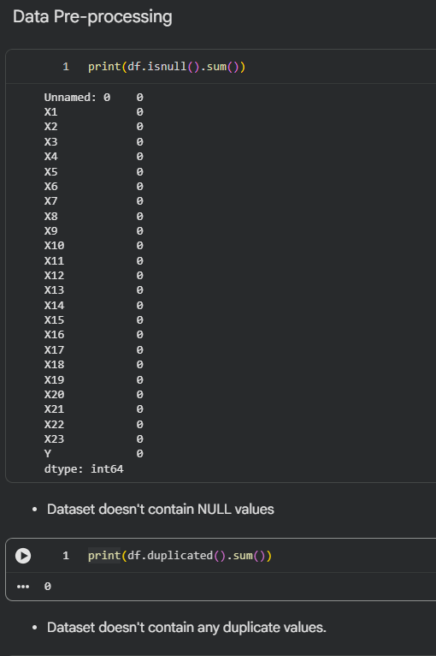
Fig 4: Null check and Duplication values check

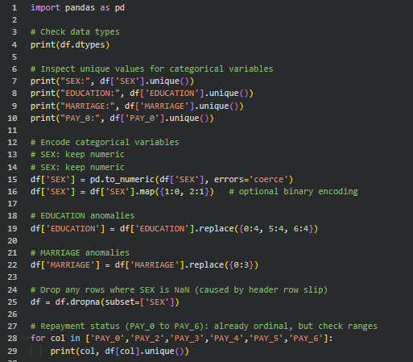
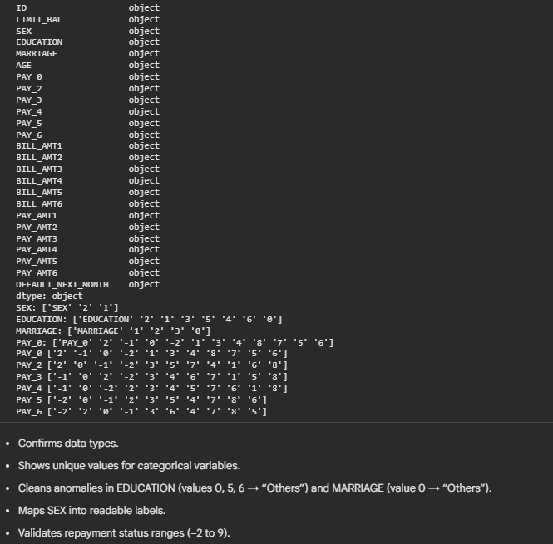
Fig 5: Unique value check
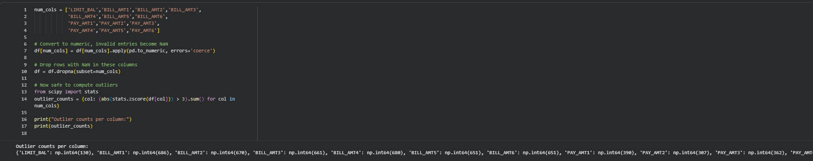
Fig 6: Checking for outliers

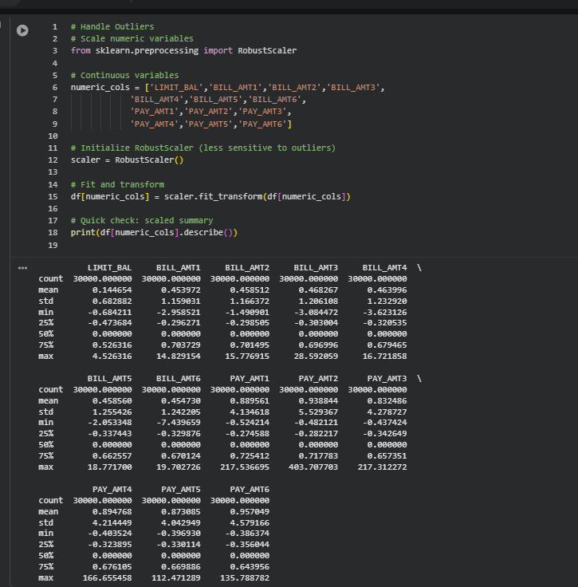
Fig 7: Handling outliers

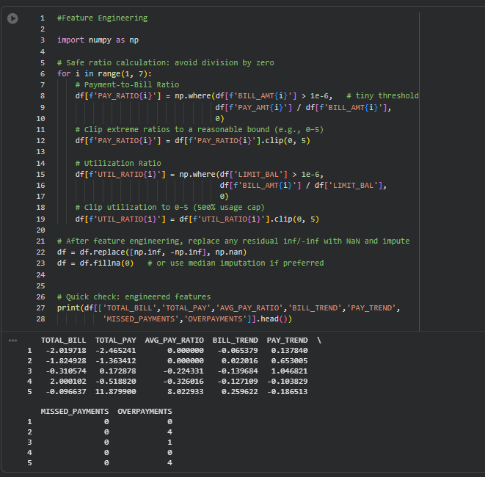
Fig 8: Feature Engineering

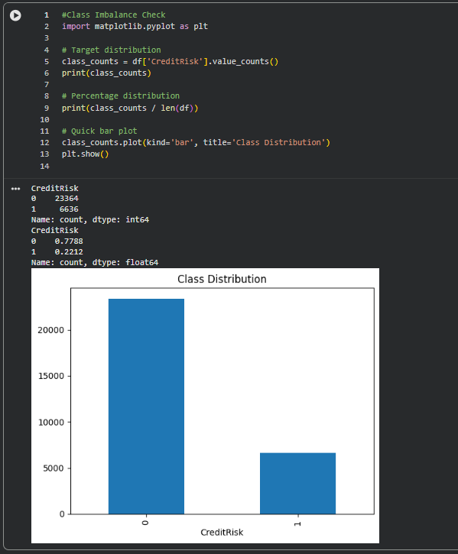
Fig 9: Class Imbalance check

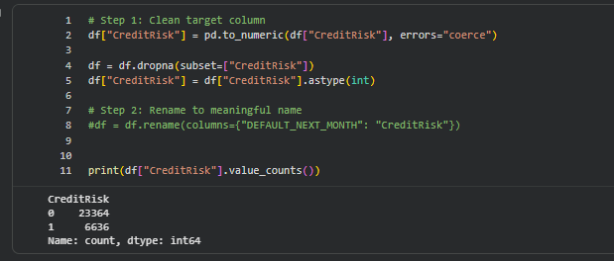
Fig 10: Cleaning target column

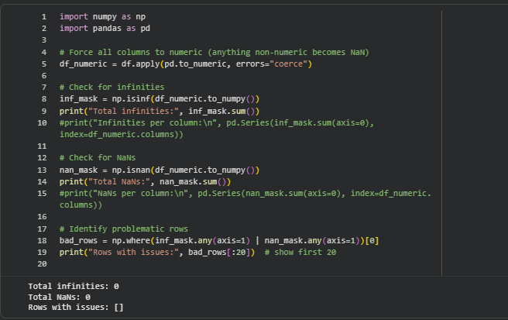
Fig 11: Checking for NaN or Infinity values

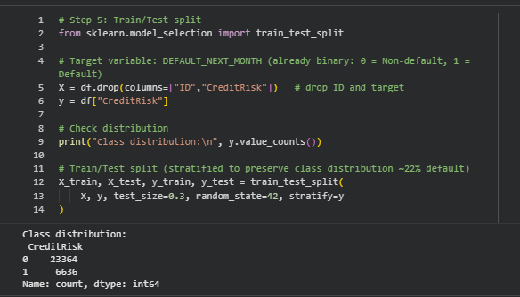
Fig 12: Test Train Split

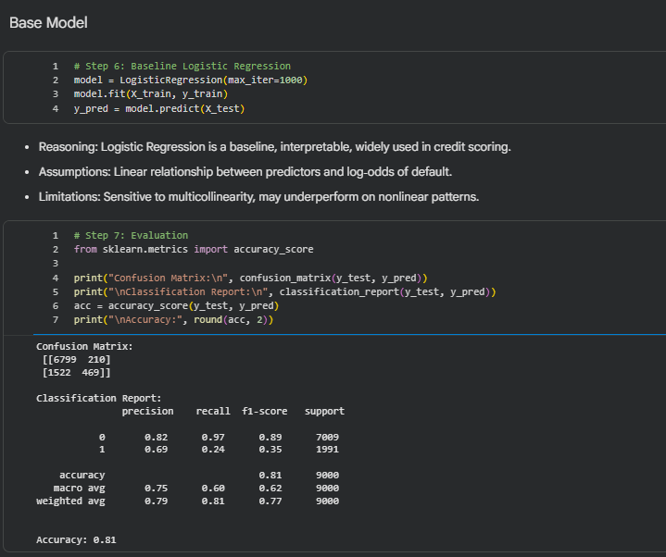
Fig 13: Logistic regression, confusion matrix and Classification Report

